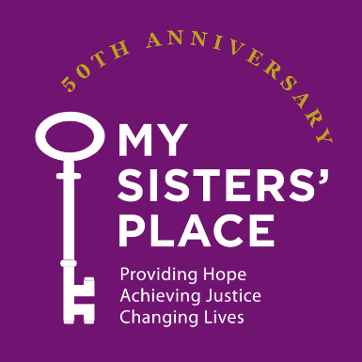
MSP Breakfast for Change
Social Media Toolkit
Thank you so much for your support of My Sisters’ Place and for helping us spread the word about our upcoming Breakfast for Change! Every post, share, introduction and conversation helps more people learn about My Sisters’ Place and the critical services available to survivors throughout Westchester County.
We’ve created this simple toolkit to make it easy to share information about the event on your social media platforms and in emails. Please feel free to copy, paste and personalize any of the suggested messages below.
Your posts help raise awareness of MSP’s work, encourage people to attend or make a donation, and introduce our organization to new supporters.
If you have questions about the images or text, or would like to customize your outreach, please contact:
Carly: clevine@mspny.org
Kayla: ktenhouse@mspny.org (beginning 9/14)

Event at a Glance
MSP Breakfast for Change
Wednesday, October 28, 2026
8:30 a.m.
Brae Burn Country Club | Purchase, NY
Theme: Open Doors, Open Futures
This year’s Breakfast for Change will highlight the vital role of emergency shelter, along with prevention and the comprehensive support survivors need to move forward safely.
Direct link to register or donate:
mspny.org/breakfast-for-change

Images
The images included in this toolkit are ready to use on Facebook, Instagram and LinkedIn.
To save an image:
- Right click the image and select “Save image” or “Save picture as.”
- If you have trouble saving an image, we can send it to you as a separate email attachment.

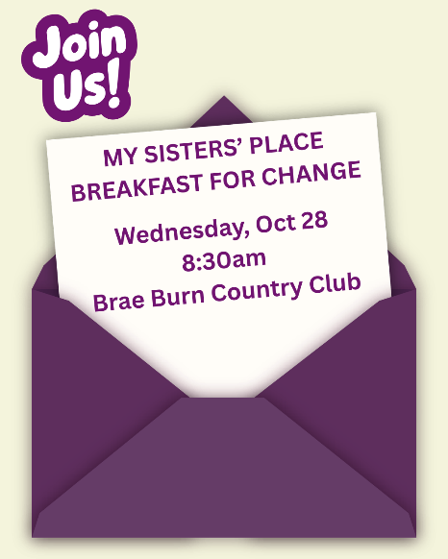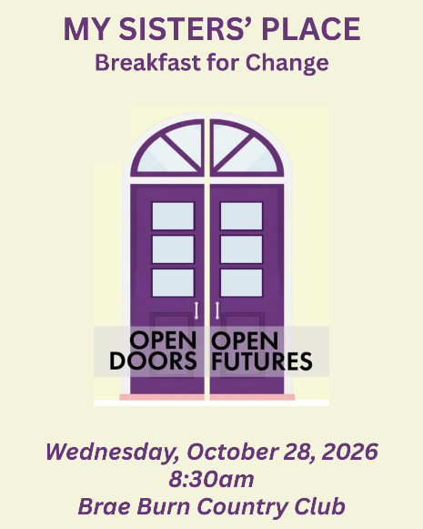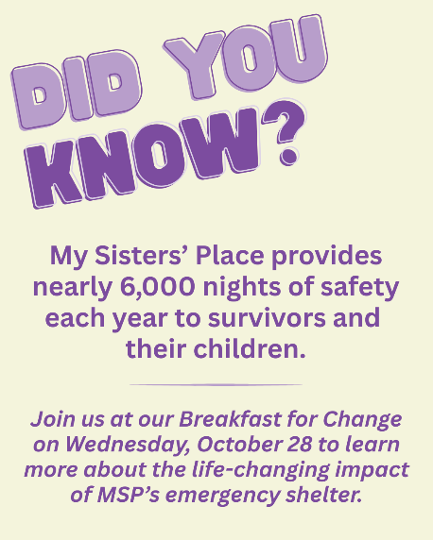

Please feel free to use the images with any of the sample captions below.

Copy & Paste: Sample Social Media Captions
Feel free to personalize these messages or add your own thoughts about why you support MSP!
1. Quick & Easy
Join me for My Sisters’ Place Breakfast for Change on Wednesday, October 28th! This year’s theme, Open Doors, Open Futures, shines a light on the vital role of emergency shelter and the support survivors need to move forward safely.
Register or donate: mspny.org/breakfast-for-change
#BreakfastForChange26 #OpenDoorsOpenFutures #MySistersPlace

2. Personal
I’m proud to support My Sisters’ Place and their upcoming Breakfast for Change on October 28th!
For 50 years, MSP has been providing safety, support and resources to survivors of domestic violence and human trafficking throughout Westchester County.
Join me for this important event and help Open Doors, Open Futures.
Register or donate: mspny.org/breakfast-for-change
#BreakfastForChange26 #OpenDoorsOpenFutures #MySistersPlace

3. Event Focus
What does it mean to open doors to a safer future?
Join My Sisters’ Place on October 28th for Breakfast for Change, featuring a conversation about the vital role of emergency shelter, prevention and comprehensive support for survivors.
Open Doors, Open Futures.
Register or donate: mspny.org/breakfast-for-change
#BreakfastForChange26 #OpenDoorsOpenFutures #MySistersPlace

4. 50 Years of MSP
For 50 years, My Sisters’ Place has been there for survivors of domestic violence and human trafficking across Westchester County.
This October, we’re coming together to make sure that support continues.
Join me at MSP’s Breakfast for Change on October 28th and help Open Doors, Open Futures.
Register or donate: mspny.org/breakfast-for-change
#BreakfastForChange26 #OpenDoorsOpenFutures #MySistersPlace

5. Make an Impact
Survivors should have access to safety, stability and support when they need it most.
My Sisters’ Place has been providing critical resources to survivors in Westchester County for 50 years. Please join me in supporting MSP’s Breakfast for Change on October 28th.
Your participation and support help make this work possible.
Register or donate: mspny.org/breakfast-for-change
#BreakfastForChange26 #OpenDoorsOpenFutures #MySistersPlace

6. Support Without Attending
Can’t attend the Breakfast for Change? You can still make an impact!
I’m proud to support My Sisters’ Place and their work to end domestic violence and human trafficking in Westchester County. If you’re able, please consider making a donation to support survivors and MSP’s vital services.
Donate: mspny.org/breakfast-for-change
#MySistersPlace #OpenDoorsOpenFutures

Hashtags
You can add any of the following hashtags to your posts:
#BreakfastForChange26
#OpenDoorsOpenFutures
#MySistersPlace
#DomesticViolenceAwareness
#HumanTraffickingAwareness
You do not need to use all of them. Two or three hashtags are plenty!

Tag MSP
When posting, please remember to tag My Sisters’ Place so we can see your post and share it with our followers.
Instagram: @mysistersplaceny
Facebook: My Sisters’ Place, Westchester, NY
LinkedIn: My Sisters’ Place NY
We’ll Share Your Post!
Tagging MSP helps us find your post so we can like, comment and/or share it with our audience.

A Few Important Reminders
Instagram:
Website links are not clickable in Instagram captions. For Instagram posts, use language such as:
Register or donate — link in bio!
If you are comfortable using Instagram Stories, you can also share the event link there.
Facebook, LinkedIn:
You can include the clickable event link directly in your post:mspny.org/breakfast-for-change

